>Create a folder called umqtt on the root of pico 2w

>Copy over a file called simple.py into the umqtt folder.

>Copy over the boot.py and the custom.py to the root of the pico 2w

>Unplug the pico from the computer and your done with the NES controller programming side.
---------------------------------------------------------------------------------------------------------------
> When you power up the NES controller. You will have to use a computer and connect to the NES Controller Setup access point mode from the NES controller.

> Once done, you will have to use a web browser going to this address “192.168.4.1”. Default password is: password123
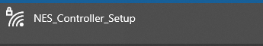

>When it opens up, you will have to type in your routers Wi-Fi SSID, Wi-Fi password, Octoprint IP address and the OctoPrint API key.
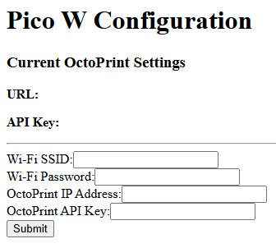

You are now done with the controller setup. Move to the OctoPrint side of things if you have not done so. The file labeled OctoPrint side of things should now be opened to continue this setup.

